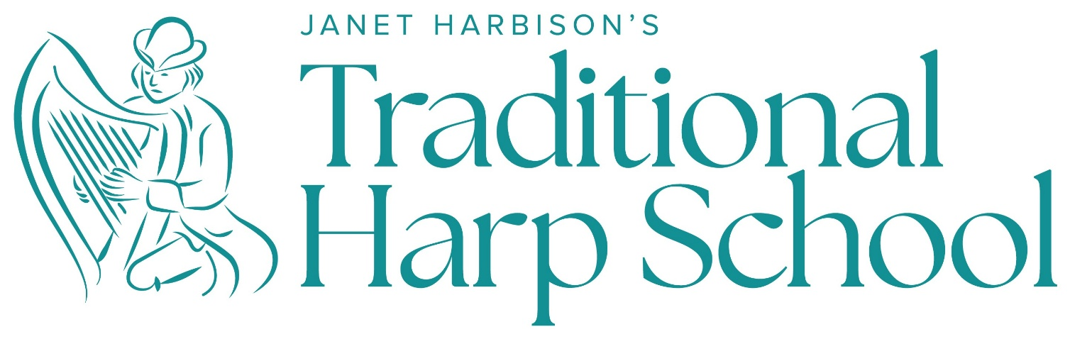

with JANET HARBISON

1-week ADULT’S

harp summer schools 2027

in Maghery, Dungloe, Co. Donegal, Ireland

June 6 - 12 * June 13–19 * June 20 - 26

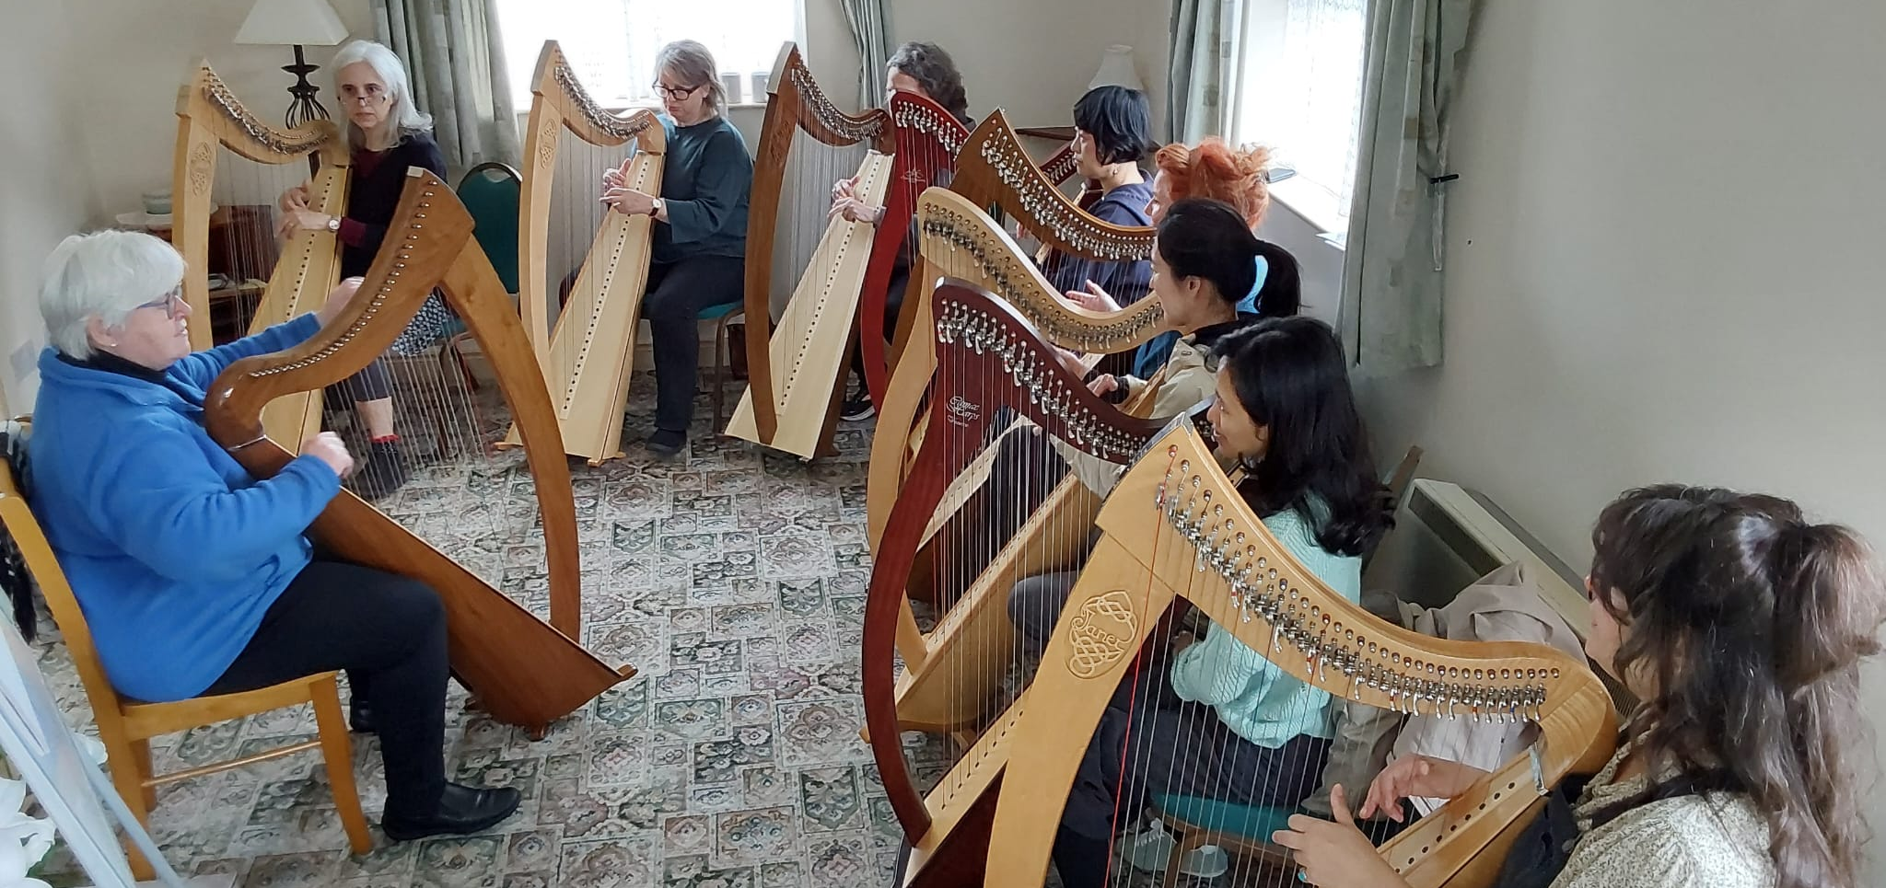

Small Summer-Schools for a Big Impact

On your Sunday to Saturday, 5-day training course, you will:

Enjoy making music!

Progress your overall harping to another level

Expand your repertoire with great new tunes

Improve your technique, listening, music logic and memory

Arrange your choice of melodies and music

Accompany song (yourself or somebody else singing)

Discover social playing and how sessions work
Adults Only Donegal Harp Weeks 2027
The Course Schedule

Sunday Arrival from 4pm onwards. (Or, come drop off your luggage and go explore!)
8.30pm Welcome Dinner ‘at home’ and easy evening

Monday 9.30-10.30am Big Warm-up! Harp Aerobics
11am – 12.30 Morning classes in sub-groups (20 min intervals with Janet)
1pm Lunch
2 – 3.30pm Afternoon classes
3.45pm Discover Maghery beach, swim, hike, explore the castle and
Strand Bar (with coffee shop and ice-cream parlour)
Discover Dungloe, Go shopping and Mystical River Walk
Dinnertime Dine out or order in (self cater) or out at the Maghery Centre
(pay your own)
8.30pm Illustrated lecture with Janet: ‘500 years a ’harping’

Tuesday 9.30-10.30am Big Warm-up! Harp Aerobics
11am – 12.30 Morning classes
1pm Lunch
2 – 3.30pm Afternoon classes
Dinnertime Dine in or eat out
8.30pm Free evening

Wednesday 9.30-10.30am Warm-up Harp Aerobics
11am – 12.30 Morning classes
1pm Lunch in No.15
Afternoon TRIP OUT to
Different options involve different costs – up to max of €30.
Dinnertime Eat out at McCafferty’s, Dungloe
8.30pm ‘Seisiún at the Ionad’ Concert featuring local musicians, singers and dancers (from Meenacross Comhaltas) in the Old Library at the top of town. Audience artistes also invited to perform. Scones and tea in the middle of the show and €5 donation is requested.

Thursday 9.30-10.30am Warm-up Harp Aerobics
11am – 12.30 Morning classes
1pm Lunch in No.15
2 – 3.30pm Afternoon classes
Dinnertime Eat out in Dungloe (Many options!)
8.30pm Concert at Templecrone, Dungloe
Janet presents the programme on a harp theme – e.g. ‘an evening with Carolan’, or ‘an evening of Harbison’. Janet is also joined by guest musicians. This concert is a fund-raiser for local community projects. (Adm. €10, free to Harp School Participants)

Friday 9.30-10.30am Warm-up Harp Aerobics
11am – 12.30 Morning classes
1pm Lunch in No.15
3 – 5pm Big round-up session for all
6pm Dinner at Danny Minnie’s (famous local restaurant) with a
great session afterwards
Bus departs at 6.30pm and returns at 11.30pm.

Saturday Breakfast and Goodbyes
ABOUT Learning by Ear

The Irish / Celtic harp tradition has been an oral/aural tradition for over a millennium – taught orally (from a teacher or within the community of players) and learned aurally (by ear). It is taught as a child learns language – from an early learner’s repertoire expanding steadily, creatively and as spontaneous as conversation. Janet has structured this method for learners of all ages and backgrounds over an experience of a half century and she teaches group classes of mixed abilities where everyone will be comfortably challenged – improving their general skills, their listening and memory skills, and building confidence in all
Core abilities:
- Physical development (toward a strong technique with agility, speed and control),
- Aural acuity (training the ear to hear fine detail and nuance),
- Logic (as music is a language that is always ‘sensible’) and
- Mental skills (toward intuitively feeling structure, scale and balance in form and rhythm). ‘M’ also includes Memory skills (toward effective management of tunes and retrieval triggers) – completing the acronym: P-A-L-M.

Essential skills:
- Melody interpretation (dressing up or dressing down the tune, and adding ornamentation and variation (which is central to the traditional style of interpretation)
- Arrangement – harmonising, adding base-lines, developing your own style with ‘good taste’; and
- Accompaniment skills – from ‘Chordscapes’ to ‘Complementing’.

Then, we will adventure (gently!) into the expansive treasure of the repertoire! This comprises:
- Historical harp music through the ages (including the music of Carolan, the Connellans, Rory Dall…)
- Beloved airs from folk songs to ‘sean nós music (old-style gaelic songs or airs)
- The world of March and Dance music - tunes played in sessions and for special occasions
- Sacred and ceremonial music (from Celtic Christian plainsong to today’s ecumenical and spiritual music),
- Singing to your own harp accompaniment (or accompany someone else playing or singing).

The ‘Traditional Harp School’ method caters to all these elements – teaching literacy after fluency. It is this method that has established the foundation for many generations of harpers – and it is now available to all teachers and students of the traditional harp, anywhere in the world.

ABOUT Janet Harbison
Janet Harbison was born in Dublin, but her family background was from central Ulster (Ireland’s northern province). A multi-award winning Irish harper, she came to Belfast in 1984 to complete her PhD on the Belfast Harpers’ Festival of 1792. At the time, Northern Ireland’s ‘Troubles’ (civil unrest) was still raging and with strong prejudices regarding music and cultural identity, the harp had disappeared from the region since partition (the separation of Northern Ireland from the Republic in 1922). Yet, Belfast, Northern Ireland’s principal city, has a very particular history with the harp … And, recognizing that the harp appealed to both sides of the conflict, Janet set about creating a concert ensemble with the harp bringing children, their families and communities together collaborating in the telling of their story in the music, song and dance of Northern Ireland – and thus the Belfast Harp Orchestra was created. Launched in April 1992 with a nationwide tour of Ireland, at the 1992 World Harp Festival Belfast in May, they forged a special relationship with ‘The Chieftains’, later performing with them in the world’s top venues including New York’s Carnegie Hall, Washington’s Kennedy Centre, the Boston Symphony Hall, London’s Royal Festival Hall, the Barbican Centre and Dublin’s National Concert Hall. Within a year, their joint recording ‘The Celtic Harp’, won the ‘Best Folk Music Album’ Grammy Award (1993) and many recordings, concert tours, film and TV features, celebrity appearances and international festivals later, over 90% of BHO members ‘went professional’ and most of today’s most celebrated harpers emerged from their ranks (including Michael Rooney and Grainne Hambly). Janet attributes her success to her use of the traditional oral method (which she has modernized for contemporary use) and her method and tutor books (published since 2004) have been in use widely throughout the world. It is widely acknowledged that the Belfast Harp Orchestra significantly contributed to the recent renaissance in Irish harping, and the world resonates healthily to the sounds of the harp today. Long may it continue to resonate!
The Course Venue

Maghery Beach Cottages, Maghery, Donegal, Ireland. F94F883
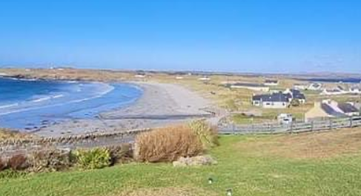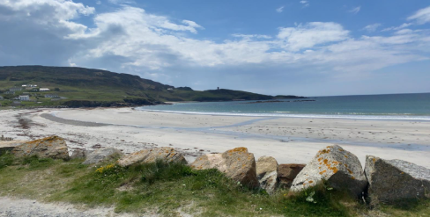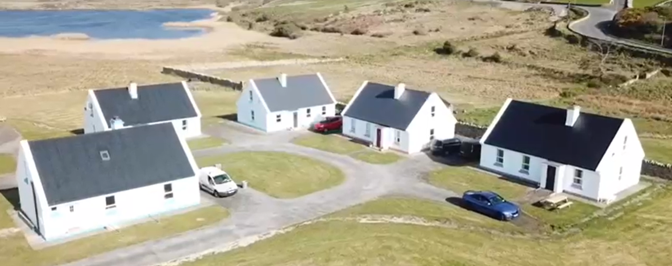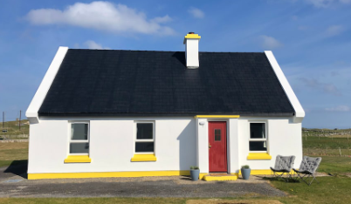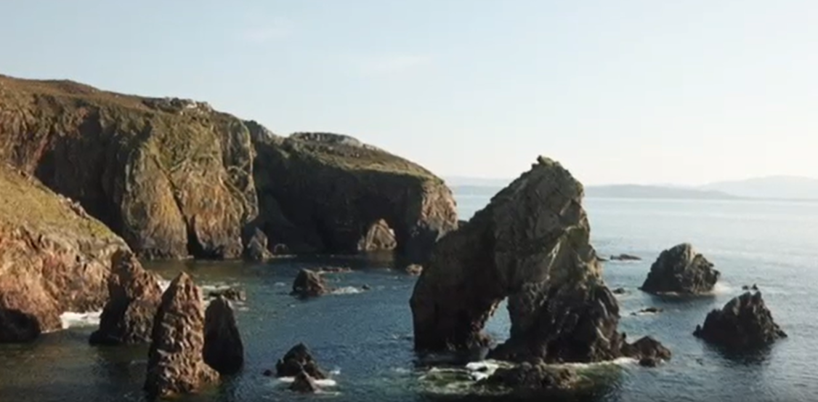
And Dungloe
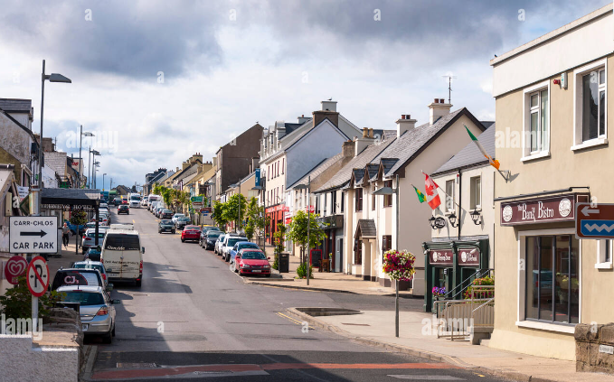
Our local town just 5 miles east, is Dungloe (Na Clochán Liath in Irish) offering superb shopping, pub culture, historic buildings and the ‘mystical riverside walk’. In the background sits the magestic Mount Errigal, Donegal's most spectacular mountain that is a favourite for climbers (mid level). At its foot is the Glenveigh National Park which comprises a vast area of magnificently beautiful bog wilderness, wonderful for walkers - and Glenveigh Castle and Gardens for those interested in the history of the area. The Wednesday afternoon trip out offers the choice of a sea-trip to Arranmore Island, Glenveagh Castle and Park, or beautiful Dunlewey by Mount Errigal with the ‘lost town of Glentorin’ …

Recommended travel arrangements

FLY into Dublin Airport, and take another flight from Dublin airport to Donegal with Aer Lingus. This takes 35 minutes, costs €40 but there are 2 flights every day at 11.40 and 18.50hrs. The airport is just a short drive from our Centre and we will pick you up.

Come by BUS from Dublin Airport or ‘Busarus’ (Dublin City Bus Centre) to Donegal town centre and there is a connecting bus for Dungloe. This is a 5 hour journey with a comfort break of 10 minutes in Cavan (midway) – very scenic but long!

Or, come by CAR taking time to explore more of our wonderful country along the Wild Atlantic Way!

For more, visit: www.JanetHarbisonHarp.com

