for
DONEGAL HARP WEEKENDS
FOR ADULTS
at Maghery Cottages, Dungloe

Name: | Phone contact + country code:
Email: | Age: (Please highlight or circle)  18-25; 25-40; 40-55; 55-70; 70+
Where in the world are you coming from: | Any allergies, food hates or disabilities?
2027: January 30 - 31 (Residents arrive Friday 29th, depart 1pm Sunday) |  |  | Mark with ‘X’
2027: March 20 - 21 (Residents arrive Friday 19th, depart 1pm Sunday)
2027: May 15 - 16 (Residents arrive Friday 14th, depart 1pm Sunday)
Additional Sunday Programme (From 1 - 10pm, Residents depart Monday morning)
Fly: Friday flight from Dublin to Donegal 12.55 – 14.00 or 18.50 – 20.00  with airport pick-ups (@ €20)  Saturday programme:  Saturday: Class 9.30am – 11, 11.30 - 1pm, 2 – 3.30pm, 4 – 5.30pm  Lunch included  We dine out (your cost) and evening session locally or at home with invited guests  Sunday programme:  Sunday morning: Mass 10am, CoI Service 11am all with harp. (No classes)  Fly: Sunday flight Donegal to Dublin: 14.30 – 15.30 (Airport bus 1pm: €20)  Additional Sunday Programme:  Sunday: Class: 2 – 3.30, 4 – 5.30pm. Dinner out & harp session 9 – 10pm.  Fly: Monday flight Donegal to Dublin: 07.55 – 08.50 (Airport bus 6.30am: €20) |  | € 240  € 120 | Enter your €€ costs HERE
Accommodation at the Maghery Cottages (the weekend venue):  ROOM (Friday and Saturday nights) Twin or Double bedroom + breakfast |  | € 250
ROOM (Sunday night) Twin or Double bedroom + breakfast |  | € 125
Harp rental for Weekend |  | € 50
Plus ones per night |  | € 50
Your total:

The Venue:
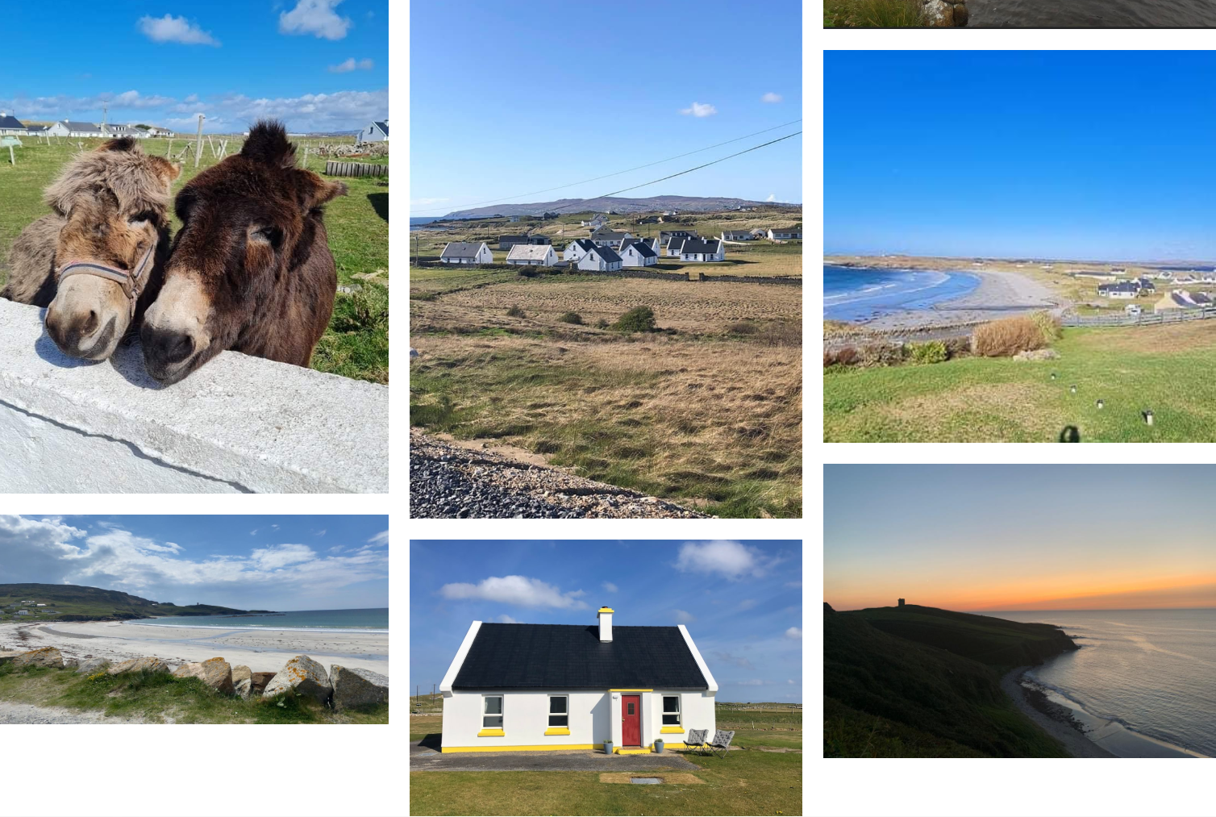
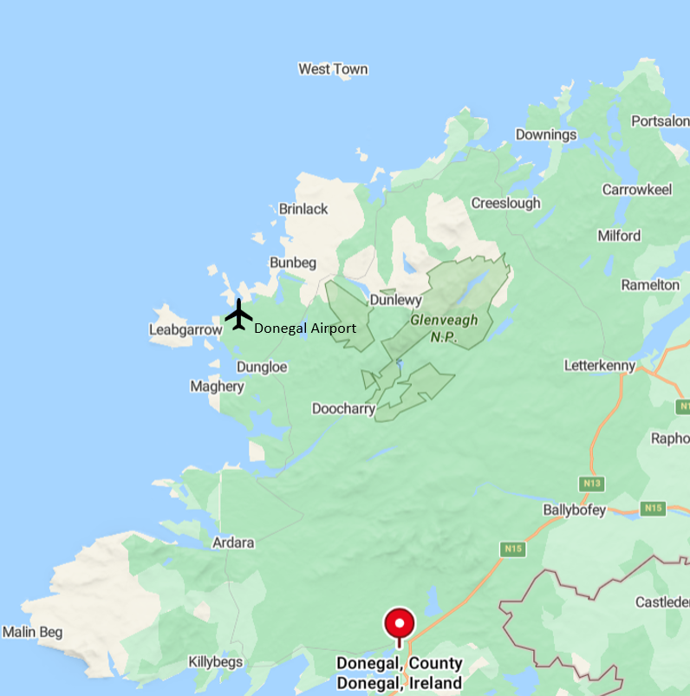

Maghery Beach Cottages are a little village complex of six traditional cottages, just a few steps from the magnificent beach of Maghery with a village pub, coffee shop, ice-cream parlour, camping ground and community centre (with a café and fish‘n’chip shop in the summer months). Fully equipped with all mod cons, central heating, self-catering facilities, open fire-places and shared ‘en suite’ bathrooms between two bedrooms. If hotel accommodation is preferred, see the many options in Dungloe (but you will need a car!).

STEPS TO BOOKING:

1 Email us at info@JanetHarbisonHarp.com to ensure there is a place for you on your chosen week(s).

2 When we confirm that a place is available, it is reserved for you for one week pending the receipt of your fee. Then, you will be sent a receipt and confirmation of your place.

3 Fees are not refundable after 2 months before the weekend date.

Payment by direct bank transfers (BACS): Preferred please!

in the Euro zone: Business account: Janet Harbison IBAN: GB88SRLG60837181494148
BIC: SRLGGB3L

in the UK: Business account: Janet Harbison
Sorting: 60-83-71 Acc. No: 41023475

Bank address (for both accounts) if required:
Starling Bank Limited, 3rd floor, 2 Finsbury Avenue, London EC2M 2PP.

Or by
Paypal in Euro, Sterling or US Dollars (based on the exchange rate on the day of your payment): Log on to www.paypal.com
Pay to info@janetharbisonharp.com

Other platforms (e.g. Wise) also possible.

