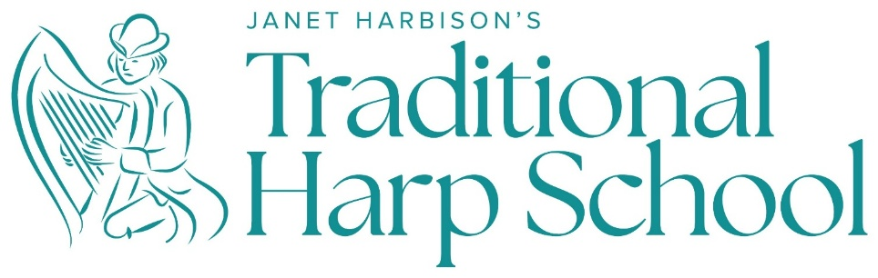

Teaching Irish Harp by Ear

(Aural Training) 7-day Teacher Training Course for Traditional Irish Harp

August 8 – 14
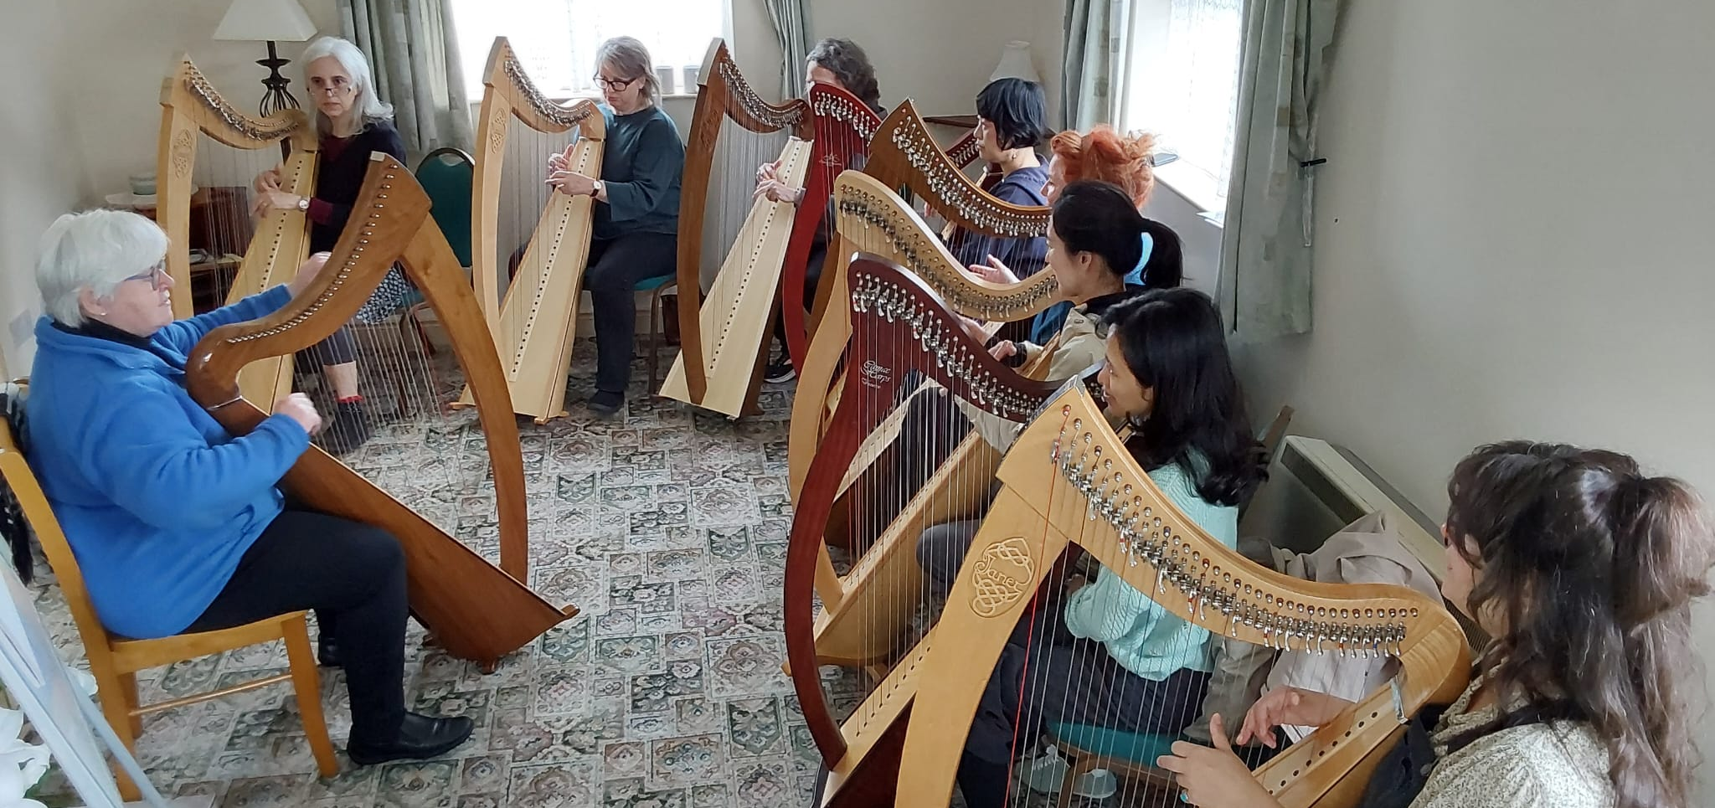

With Janet Harbison, D.Litt., MA (Music & Psych), LTCL, TTCT
Director of the Irish Harp Centre 2002-2016 Director of the Belfast Harp Orchestra (Grammy Award Winners with The Chieftains, 1992-2002), Irish (1999-2023) and Irish Youth (2005-2016) Harp Orchestras Research Fellow, Institute of Irish Studies, Queen’s University Belfast Visiting Professor (Music), Ulster University (2016-2020) Irish Research Council Scholar (2022-) Teacher of many of Ireland’s most distinguished harpers today.

The Teachers’ Course Schedule 2027

Sunday Teacher Training Day
11am – 12.30 Teacher Training Session 1
Introduction to ‘Traditional Irish Harp: History and Repertoires’
2 – 3.30pm Teacher Training Session 2
‘Traditionality’ – the why’s and wherefore’s!
4 – 5.30pm Teacher Training Session 3
Experience a ‘lesson’ from ‘Warm-ups’ and chord drills to application
8.30pm Dinner and easy evening

Monday 8 – 9 Teacher Training Session 4
Goals, values and fundamentals: Methods, Dimensions and Vocabulary
9.30 – 12.30 Morning classes for all (Teachers included)
2 – 3.30pm Afternoon classes for all
4 – 5.30 Teacher Training Session 5
Establishing ‘traditional’ practise
Assessment: Physical; Aural; Logic and Mental Skills (PALM)
Dinnertime Dine out or order in (self cater) or out at the Maghery Centre (pay your own)
8.30pm Illustrated lecture with Janet: ‘500 years a ’harping’

Tuesday 8 – 9 Teacher Training Session 6
How Structured Oral Learning Works: On Concepts and Constructions
11am – 12.30 Morning classes for all
1pm Lunch
2 – 3.30pm Afternoon classes for all
Dinnertime Dine in or eat out
8.30pm Teacher Training Session 7
Anatomy of Oral Teaching - Practical Leading Skills:
Lead * Break * Loop * Build * Play blind * Review

Wednesday 8 – 9am Teacher Training Session 8
Literacy – its essential values, history and how to teach it
9.30 – 12.30 Morning classes for all with teaching practise for teachers
Afternoon off TRIP OUT to
Different options involve different costs – up to max of €30.
8pm ‘Seisiún at the Ionad’ Concert featuring local musicians, singers and dancers (from Meenacross Comhaltas) in the Old Library at the top of town. Audience artistes also invited to perform. Scones and tea in the middle of the show and €5 donation is requested.

Thursday 9.30-10.30am Morning classes for all with teaching practise for teachers
2 – 3.30 Afternoon classes for all with teaching practise for teachers
3.45 – 5pm Teacher Training Session 9 Remedial Strategies
Dinnertime Eat out in Dungloe (Many options!)
8pm Public Concert with Janet and guests at Templecrone (CoI) Church
Janet presents the programme on a harp theme – e.g. ‘an evening with Carolan’, or ‘an evening of Harbison’. Janet is also joined by guest musicians. This concert is a fund-raiser for local community projects. (Adm. €10, free to Harp School Participants)

Friday 8 – 9.30am Teacher Training Session 10
Admin and legal issues. Review and discussion
10 – 1pm Morning classes for all with teaching practise for teachers
3 – 5pm Final Session for everyone
6pm Dinner at Danny Minnie’s (famous local restaurant) with a great session afterwards
Bus departs at 6.30pm and returns at 11.30pm.

Saturday Breakfast and Goodbyes
Teaching / Learning by Ear
The Irish / Celtic harp tradition has been an established and celebrated oral/aural tradition from at least the 9th century – taught orally by seniors or from the immersion experience within the community of players. This is also termed ‘learning by ear’ – and is an organic rather than linear learning method. It can be compared to a child’s learning of language – from the simple to the complex – participating at normal speed from the outset, but with the detail embraced as the skills develop. From simple melody to embellished performance, the core elements are developed through steady, logical, flexible and playful engagement, with fluency prioritised before literacy, and the student participating meaningfully at every stage in the process. The ‘Traditional Harp School’ method addresses the core abilities, skills, and repertoire – logically, healthily and effectively for every player’s journey toward creative freedom and instrumental mastery. The core elements are:
Core Physical Abilities:
- Physical development (toward a strong technique with agility, speed and control),
- Aural acuity (training the ear to hear fine detail and nuance),
- Logic (as music is a language that is always ‘sensible’) and
- Mental skills (toward intuitively feeling structure, scale and balance in form and rhythm). ‘M’ also includes Memory skills (toward effective management of tunes and retrieval triggers)
– completing the acronym: P-A-L-M.

Core Musical Skills:
- Melody interpretation (dressing up or dressing down the tune, and adding ornamentation and variation (which is central to the traditional style of interpretation)
- Historical music and Planxties (including the music of Carolan, the Connellans, Rory Dall…)
- March and Dance music of social play and special occasions
- Sacred and ceremonial music from plainsong to spiritual and ritual music,

The ‘Traditional Harp School’ method has established the foundation for many of Ireland’s most celebrated harpers today – and is now available to all teachers and students of traditional harp, anywhere in the world. It is currently addressing the process of formal accreditation – which it hopes to achieve in the next years.
The ‘Traditional Harp School’ method caters to all these elements – teaching literacy after fluency. It is this method that has established the foundation for many generations of harpers – and it is now available to all teachers and students of the traditional harp, anywhere in the world.

ABOUT Janet Harbison
ABOUT Janet Harbison Janet Harbison was born in Dublin, but her family background was from central Ulster (Ireland’s northern province). After some years performing an internationally as a multy-award winning Irish harper, she came to Belfast in 1984 to complete her PhD on the Belfast Harpers’ Festival of 1792. At the time, Northern Ireland’s ‘Troubles’ (civil unrest) was still raging and with strong prejudices regarding music and cultural identity, the harp had disappeared from the region since partition (the separation of Northern Ireland from the Republic in 1922). Yet, Belfast, Northern Ireland’s principal city, has a very particular history with the harp dating from the Harpers’ Festival of 1792…And, employed as Curator of Music at the Ulster Folk Museum, a Dept of Education facility, and addressing the policy of ‘Education toward Mutual Understanding’, Janet created a harp concert ensemble to bring children, their families and communities together - collaborating in the telling of their story in Northern Ireland’s music, song and dance – and the Belfast Harp Orchestra was created. Formally launched at the 1992 World Harp Festival Belfast (organized for the Bicentenary), the BHO performed the opening concert with ‘The Chieftains’ - who were so delighted that they took the orchestra on tour with them afterwards, performing in the world’s top venues including New York’s Carnegie Hall, Washington’s Kennedy Centre, the Boston Symphony Hall, London’s Royal Festival Hall, the Barbican Centre and Dublin’s National Concert Hall – all within their first year. Their joint recording ‘The Celtic Harp’ won the Grammy Award for ‘Best Folk Music Album’ (1993). Many recordings, concert tours, film and TV features, celebrity appearances and international festivals later, over 90% of BHO members ‘went professional’ and most of today’s most celebrated harpers emerged from the BHO ranks (including Michael Rooney and Grainne Hambly). Janet attributes her success to oral teaching which she honed over her half century’s experience completing the learning path ‘from first lesson to profession’.
The Course Venue

Maghery Beach Cottages, Maghery, Donegal, Ireland. F94F883
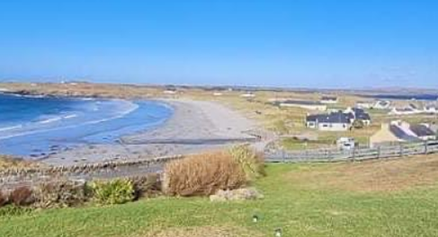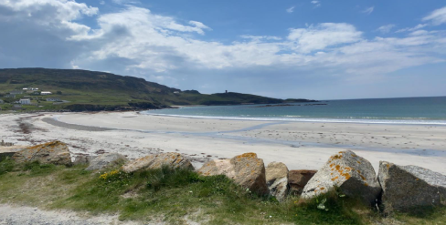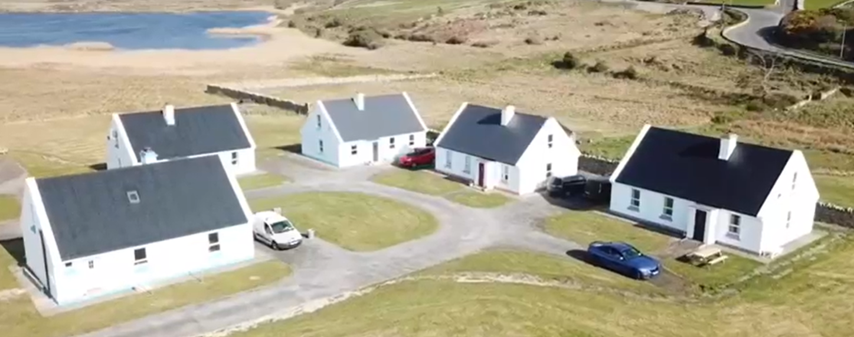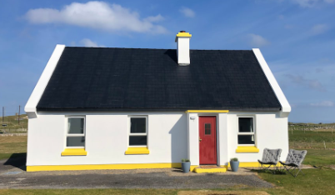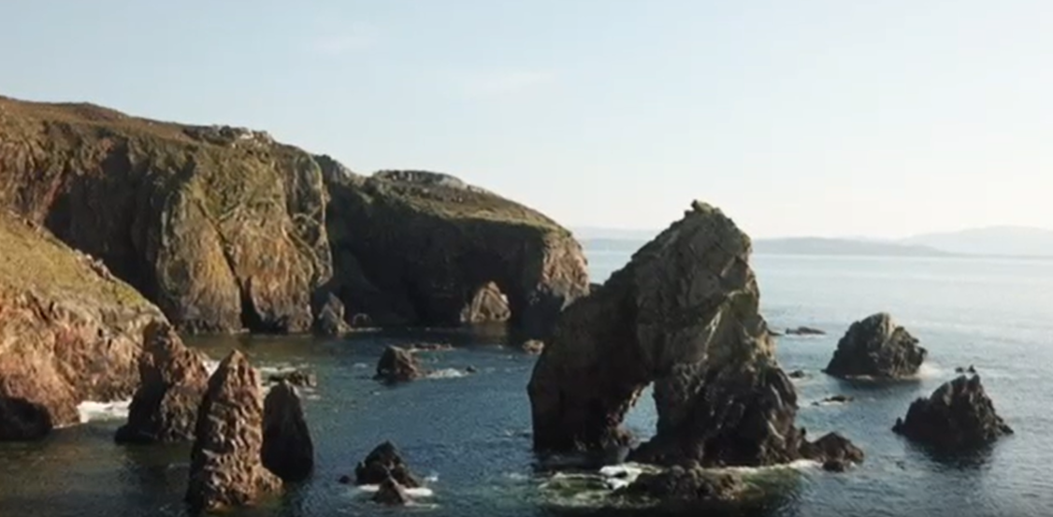
And Dungloe
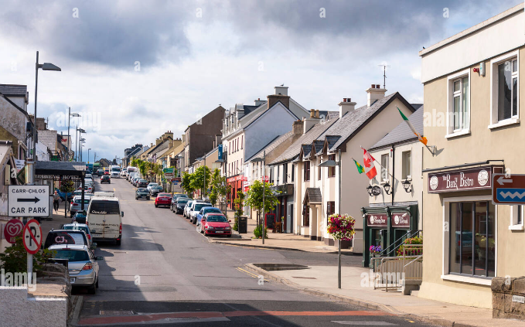
Our local town just 5 miles east, is Dungloe (Na Clochán Liath in Irish) offering superb shopping, pub culture, historic buildings and the ‘mystical riverside walk’. In the background sits the magestic Mount Errigal, Donegal's most spectacular mountain that is a favourite for climbers (mid level). At its foot is the Glenveigh National Park which comprises a vast area of magnificently beautiful bog wilderness, wonderful for walkers - and Glenveigh Castle and Gardens for those interested in the history of the area. The Wednesday afternoon trip out offers the choice of a sea-trip to Arranmore Island, Glenveagh Castle and Park, or beautiful Dunlewey by Mount Errigal with the ‘lost town of Glentorin’ …

Recommended travel arrangements

FLY into Dublin Airport, and take another flight from Dublin airport to Donegal with Aer Lingus. This takes 35 minutes, costs €40 but there are 2 flights every day at 11.40 and 18.50hrs. The airport is just a short drive from our Centre and we will pick you up.

Come by BUS from Dublin Airport or ‘Busarus’ (Dublin City Bus Centre) to Donegal town centre and there is a connecting bus for Dungloe. This is a 5 hour journey with a comfort break of 10 minutes in Cavan (midway) – very scenic but long!

Or, come by CAR taking time to explore more of our wonderful country along the Wild Atlantic Way!

For more, visit: www.JanetHarbisonHarp.com

